Step 1: Use the Python Code to make the CSV file. ( or Generate it via ChatGPT/Gemini/Co-Pilot/Claude)
Python Code-
import csv, random
from datetime import datetime, timedelta

# Configurations
num_customers = 20000
num_bookings = 60000

# Room Types
room_types = [
{"RoomTypeID": "RT1", "RoomType": "Single", "Price": 2500, "MaxOccupancy": 1, "Amenities": "WiFi,TV", "IsAC": True, "IsSeaFacing": False}
]

branches = [
{"BranchID": "B1", "BranchName": "HotelRev Theni", "City": "Theni", "State": "Tamil Nadu", "ManagerName": "Mr. Rajan", "Phone": "9876543210", "StarRating": 4, "RoomCount": 40, "RevenueScore": 78.5, "HasPool": True, "HasConferenceRoom": True}

]

customers = [
{"CustomerID": "C001", "Name": "Aarav Sharma", "City": "Delhi", "State": "Delhi"}]

customer_names = [
"Aarav Sharma", "Kavya Mehta", "Rohan Kapoor", "Simran Singh", "Ishaan Verma", "Tanya Bhatia", "Aditya Malhotra", "Neha Chauhan", "Rajat Sethi"]

# Customer Attributes
nationalities = ['Indian']
loyalty_tiers = ['Bronze', 'Silver', 'Gold', 'Platinum']
age_groups = ['18-25', '26-35', '36-50', '51+']
genders = ['Male', 'Female', 'Other']

# Booking Attributes
booking_statuses = ['Cancelled', 'Checked-in', 'No-show']
cancellation_reasons = ['Price', 'Change of plans', 'Weather', 'Other']
payment_methods = ['Credit Card', 'UPI', 'Cash', 'Corporate Account']
booking_channels = ['Website', 'Mobile App', 'Travel Agent', 'Call Center']
purpose_booking = ['Business','Vacation','Conference','Holiday','']

# Generate Customers
def generate_customers():
customers = []
for i in range(num_customers):
cid = f"C{i+100}"
name = f"Customer_{i+1}"
name = random.choice(customer_names)
email = f"{name.lower()}@example.com"
phone = f"9{random.randint(100000000, 999999999)}"
nationality = random.choice(nationalities)
tier = random.choice(loyalty_tiers)
age = random.choice(age_groups)
gender = random.choice(genders)
customers.append([cid, name, email, phone, nationality, tier, age, gender])
return customers

# Generate Bookings
def generate_bookings(customers):
bookings = []
for i in range(num_bookings):
bid = f"BK{i+1000}"
customer = random.choice(customers)
room = random.choice(room_types)
branch = random.choice(branches)
check_in = datetime.today() - timedelta(days=random.randint(0, 2182))
duration = random.randint(1, 12)
check_out = check_in + timedelta(days=duration)
revenue = room['Price'] * duration
status = random.choice(booking_statuses)
cancel_reason = random.choice(cancellation_reasons) if status == 'Cancelled' else ''
lead_time = random.randint(0, 15)
payment = random.choice(payment_methods)
discount = random.choice([0, 5, 10, 15, 20])
channel = random.choice(booking_channels)
purpose = random.choice(purpose_booking)

bookings.append([
bid, customer[0], room['RoomTypeID'], branch['BranchID'],
check_in.strftime('%Y-%m-%d'),
check_out.strftime('%Y-%m-%d'),
duration, revenue, status, cancel_reason,
lead_time, payment, discount, channel,purpose
])
return bookings

# Write CSVs
def write_csv(filename, header, data):
with open(filename, mode='w', newline='') as file:
writer = csv.writer(file)
writer.writerow(header)
writer.writerows(data)

# Generate and save all tables
customers = generate_customers()
bookings = generate_bookings(customers)

write_csv('Customer.csv', ['CustomerID', 'Name', 'Email', 'Phone', 'Nationality', 'LoyaltyTier', 'AgeGroup', 'Gender'], customers)
write_csv('RoomType.csv', ['RoomTypeID', 'RoomType', 'Price', 'MaxOccupancy', 'Amenities', 'IsAC', 'IsSeaFacing'], [list(r.values()) for r in room_types])
write_csv('Branch.csv', ['BranchID', 'BranchName', 'City', 'Phone', 'ManagerName', 'StarRating', 'HasPool', 'HasConferenceRoom'], [list(b.values()) for b in branches])
write_csv('Booking.csv', ['BookingID', 'CustomerID', 'RoomTypeID', 'BranchID', 'CheckInDate', 'CheckOutDate', 'Duration', 'Revenue', 'BookingStatus', 'CancellationReason', 'LeadTime', 'PaymentMethod', 'DiscountApplied', 'BookingChannel'], bookings)

print("✅ Advanced CSVs generated: Booking.csv, Customer.csv, RoomType.csv, Branch.csv")

[There are other attributes to be added in the combined excel file, that has been shown in the Screenshots in the next pages]

Step 2: Understanding Excel File

Total Sheets to be made:

Sheets made by the Python Code:
In Bookings:  - BookingID  - CustomerID  - RoomTypeID  - BranchID  - DateID  - CheckInDate  - CheckOutDate  - Duration  - RoomType  - Revenue  - BookingStatus  - CancellationReason  - LeadTime  - PaymentMethod  - DiscountApplied  - BookingChannel  - Purpose  - StayType  - SourceType  - GuestType  - RoomNightsSold  - CustomerCluster | In Branch:  - BranchID  - BranchName  - City  - State  - Manager'sName  - Manager'sNumber  - StarRating  - RoomCount  - RevenueScore  - HasPool  - HasConference  - HasGym  - HasSpa  - HasRestaurant  - HasBar  - HasGarden  - HasValetService
In Customers:  - Name  - Email  - Phone  - Gender  - LoyaltyTier  - AgeGroup  - Nationality  - Country | In Date:  - DateID  - CheckInDate  - Day  - Month  - Year  - Weekday  - CheckOutDate  - Day  - Month  - Year  - Weekday  - DurationOfStay
In RoomType:
- RoomTypeID
- RoomType
- PricePerDay
- MaxOccupancy
- Amenities
- HasAC
- IsSeaFacing

For CalculationTable:

(Finding StayDate)
Step 1: Copy Columns - CustomerID, CheckInDate, CheckOutDate, Duration to new Sheet

Step 2: Then, Data -> From Table/Range -> Add Column -> Custom Column

New column name : StayDate
Custom column formula :
= if [CheckInDate] <> null and [CheckOutDate] <> null then
List.Dates(Date.From([CheckInDate]), Duration.Days([CheckOutDate] - [CheckInDate]), #duration(1,0,0,0))
else
null

'Expand to New Rows'

Step 3: Then, Transform -> Group By

Step 4: Change New column name to “Rooms Booked Count”

Step 5: Then, Home -> Close and Load to

Step 6: Rename the New Sheet as “CalculationTable”

For Year & Monthly Data
Step 1: Click on ‘CalculationTable’ Slide
Step 2: Insert -> PivotTable
Step 3: Rename to “Year & Monthly Data”

For Booking_Details
Step 1: Copy ‘StayDate’ and ‘Room Booked’ and paste it in the Sheet
Step 2: Add new Rows i.e., Revenue, Rooms Available Count, Occupancy %, ADR, REVpar
Step 3: Rename to “Booking_Details”

For BookingsTable
Step 1: Copy ‘BookingID’, ‘CustomerID’, ‘RoomTypeID’, ‘BranchID’, ‘DateID’, ‘CheckInDate’, ‘CheckOutDate’, ‘Duration’, ‘Revenue’ and ‘StayDate’ and paste it in the Sheet
Step 2: Add new Row i.e., DayRevenue = ‘Revenue’/’Duration’
Step 3: Add new Row i.e., MonthStart = [ =DATE(YEAR(X), MONTH(X), 1) ]
Step 4: Rename to “BookingsTable”

For RatesTable
Step 1: Copy ‘RoomTypeID’ and ‘Price’ and paste it in the Sheet
Step 2: Rename to “RatesTable”

For Duration Details
Step 1: Copy ‘BookingID’, ‘CustomerID’, ‘RoomTypeID’, ‘BranchID’, ‘DateID’, ‘CheckInDate’, ‘CheckOutDate’, ‘Duration’, ‘Revenue’ and paste it in the Sheet
Step 2: Rename to “Duration Details”

Step-2: What’s inside Excel File?
Booking_Details:
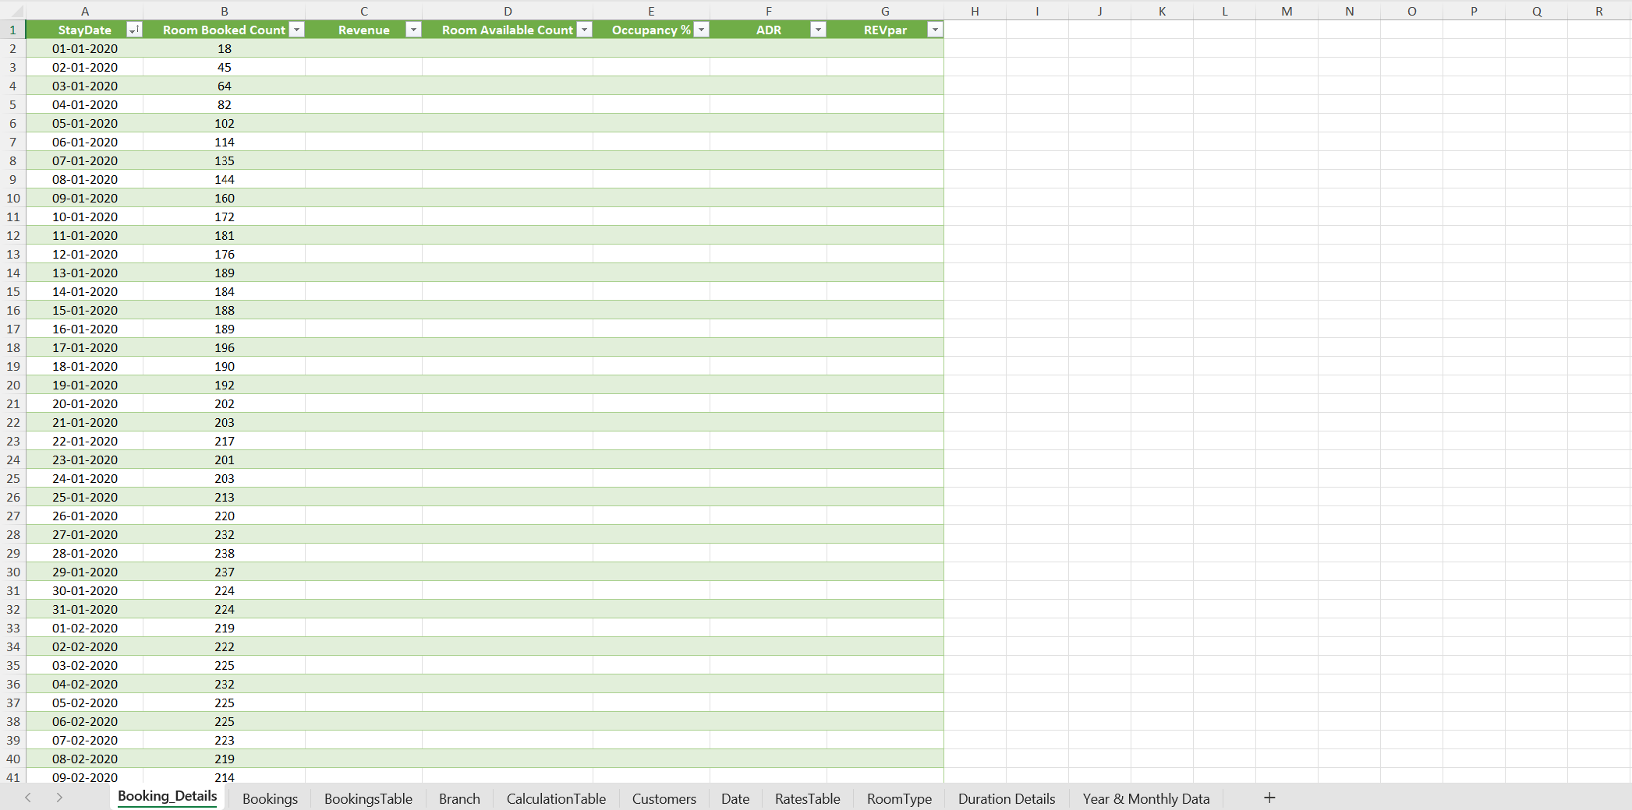

Bookings:
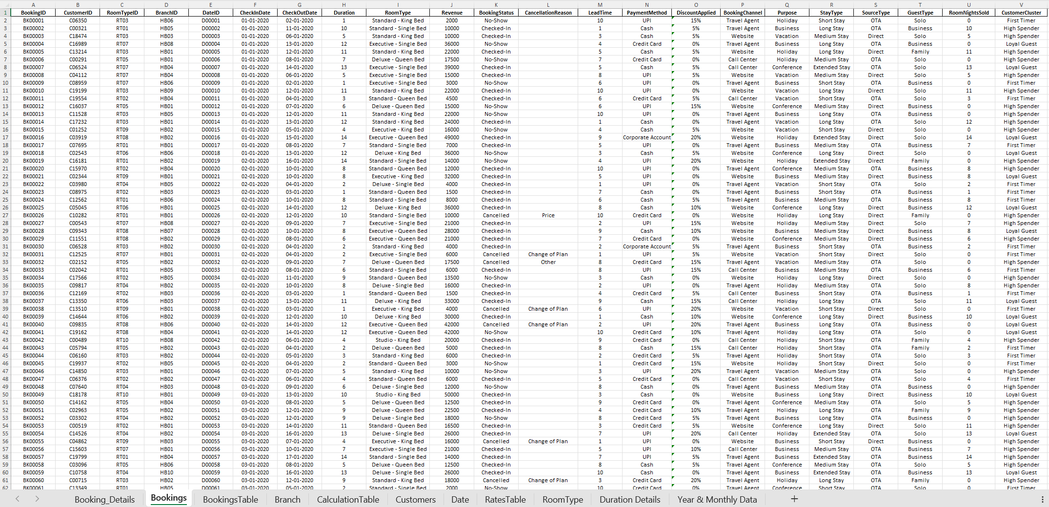

BookingsTable:
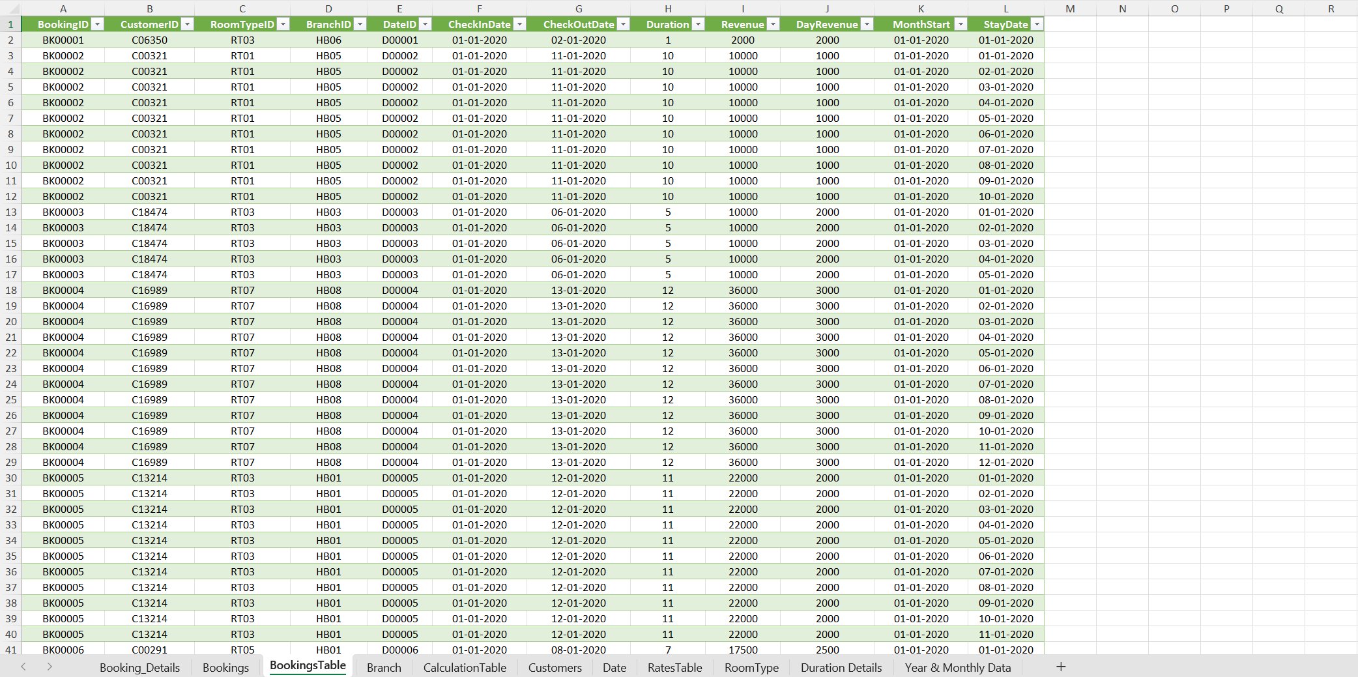

Branch:
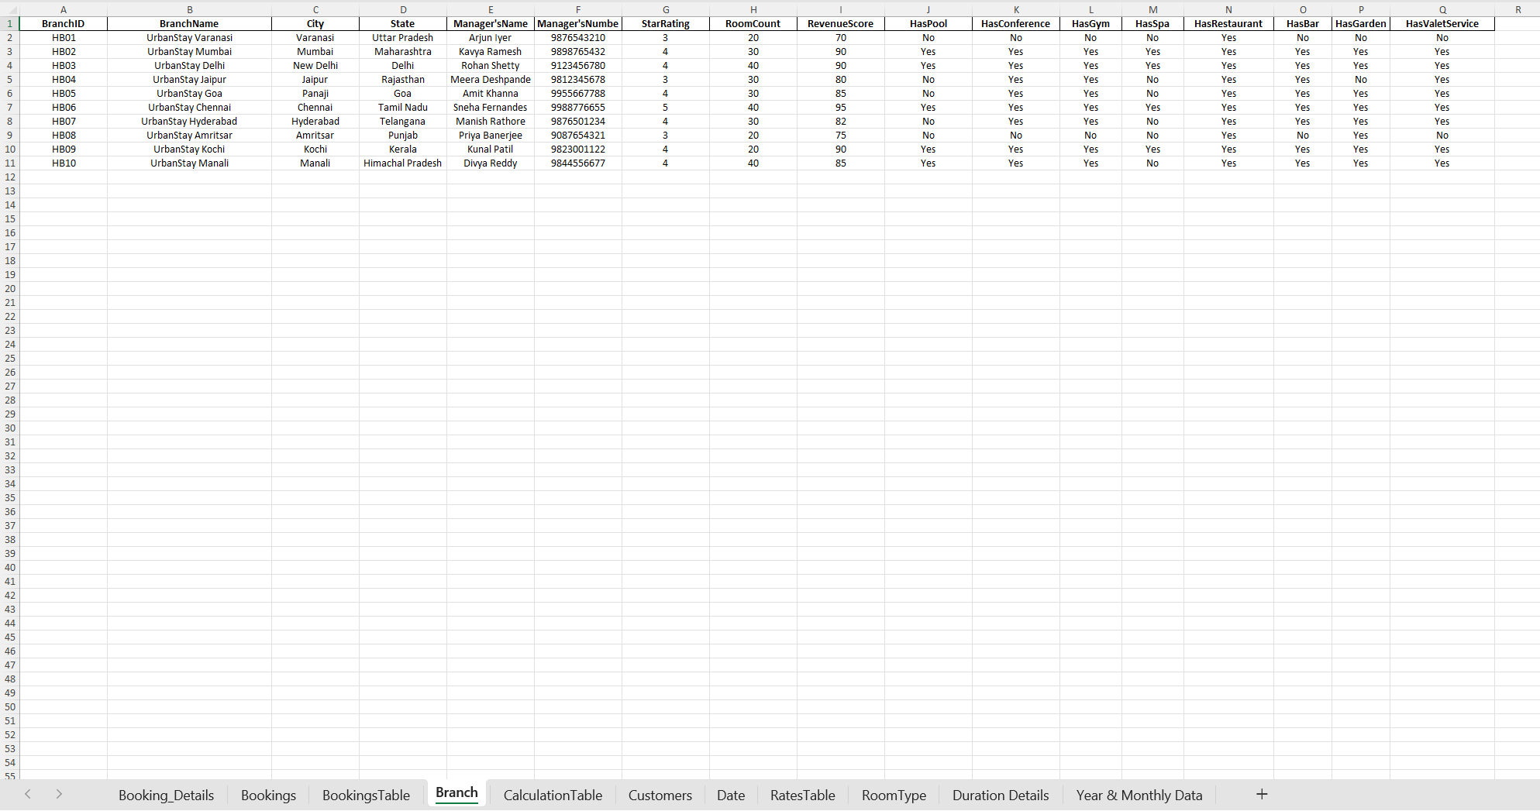

CalculationTable:
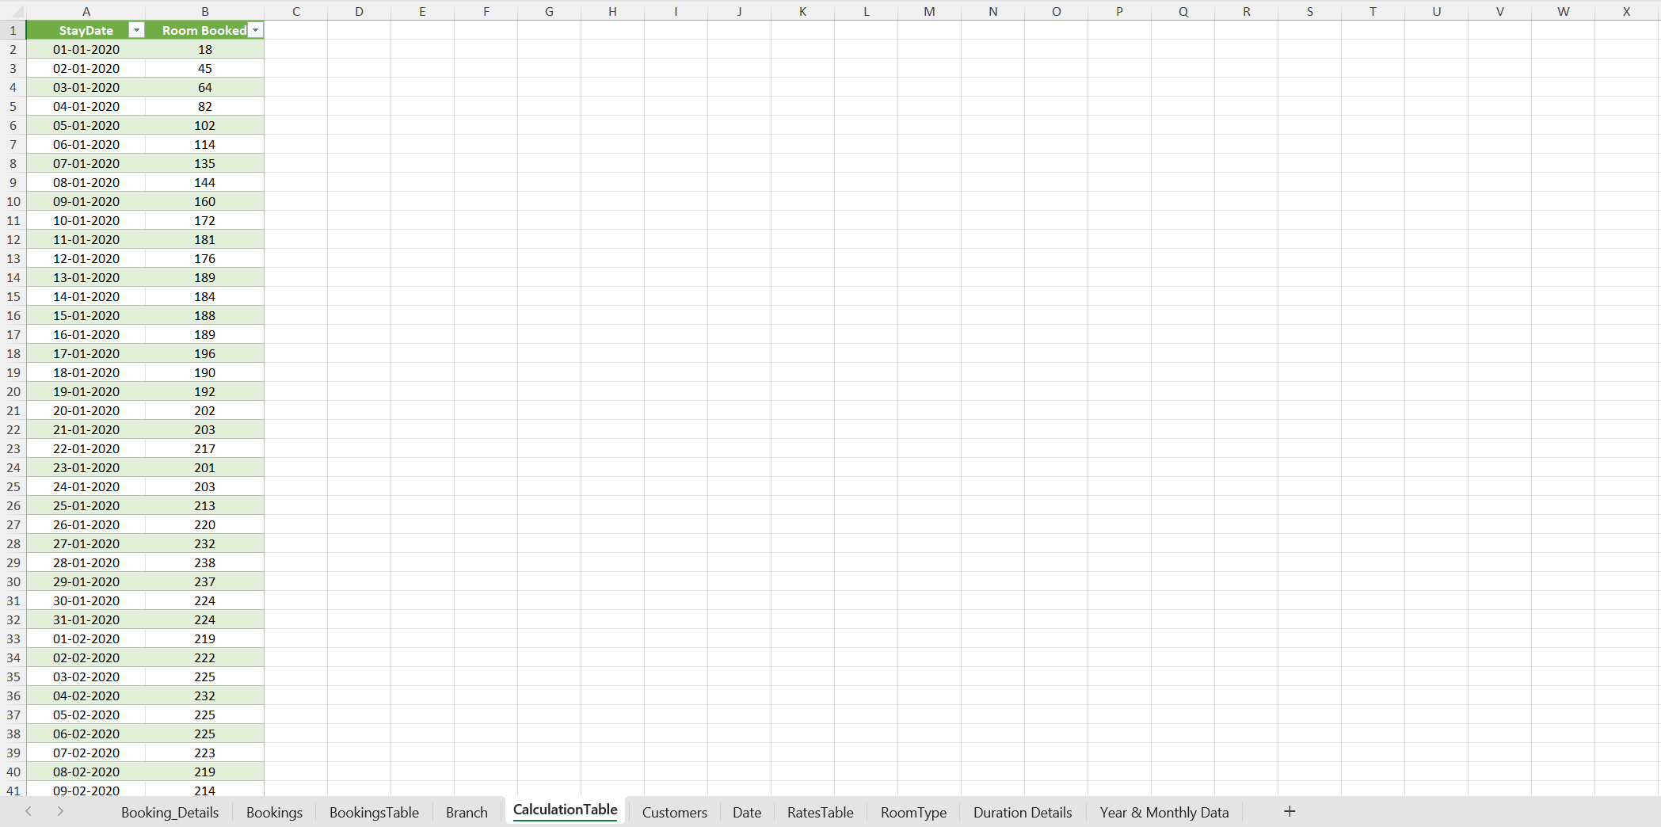

Customers:
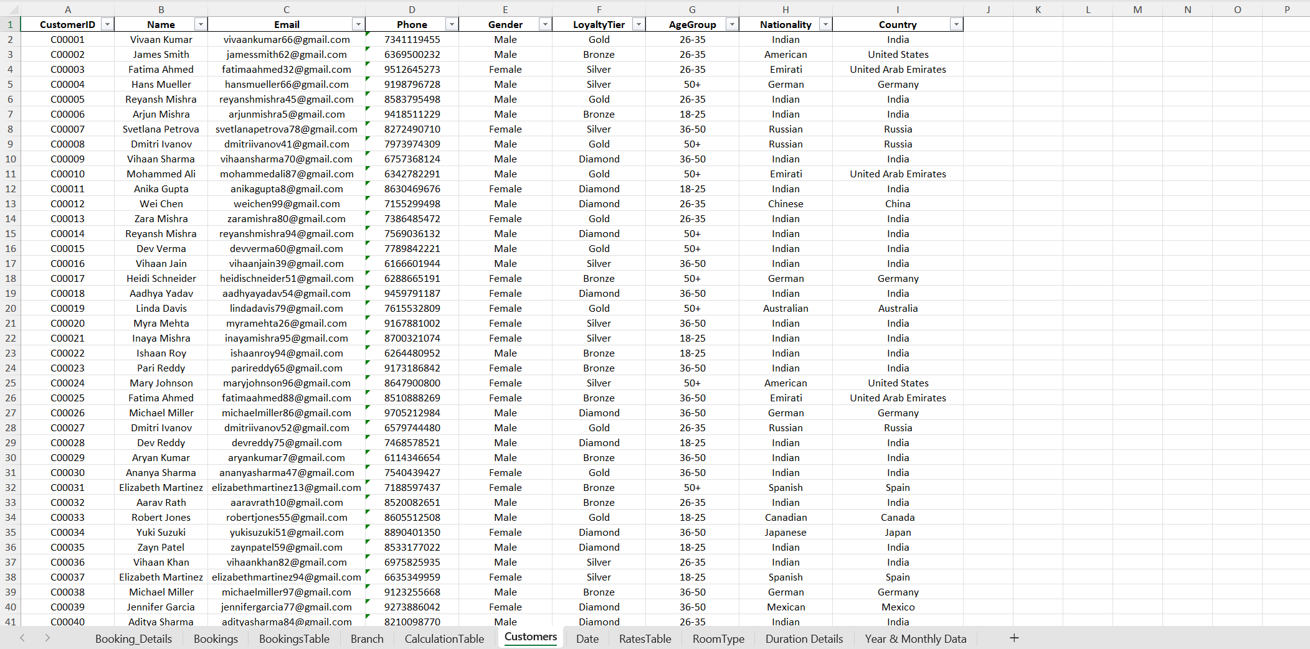

Date:
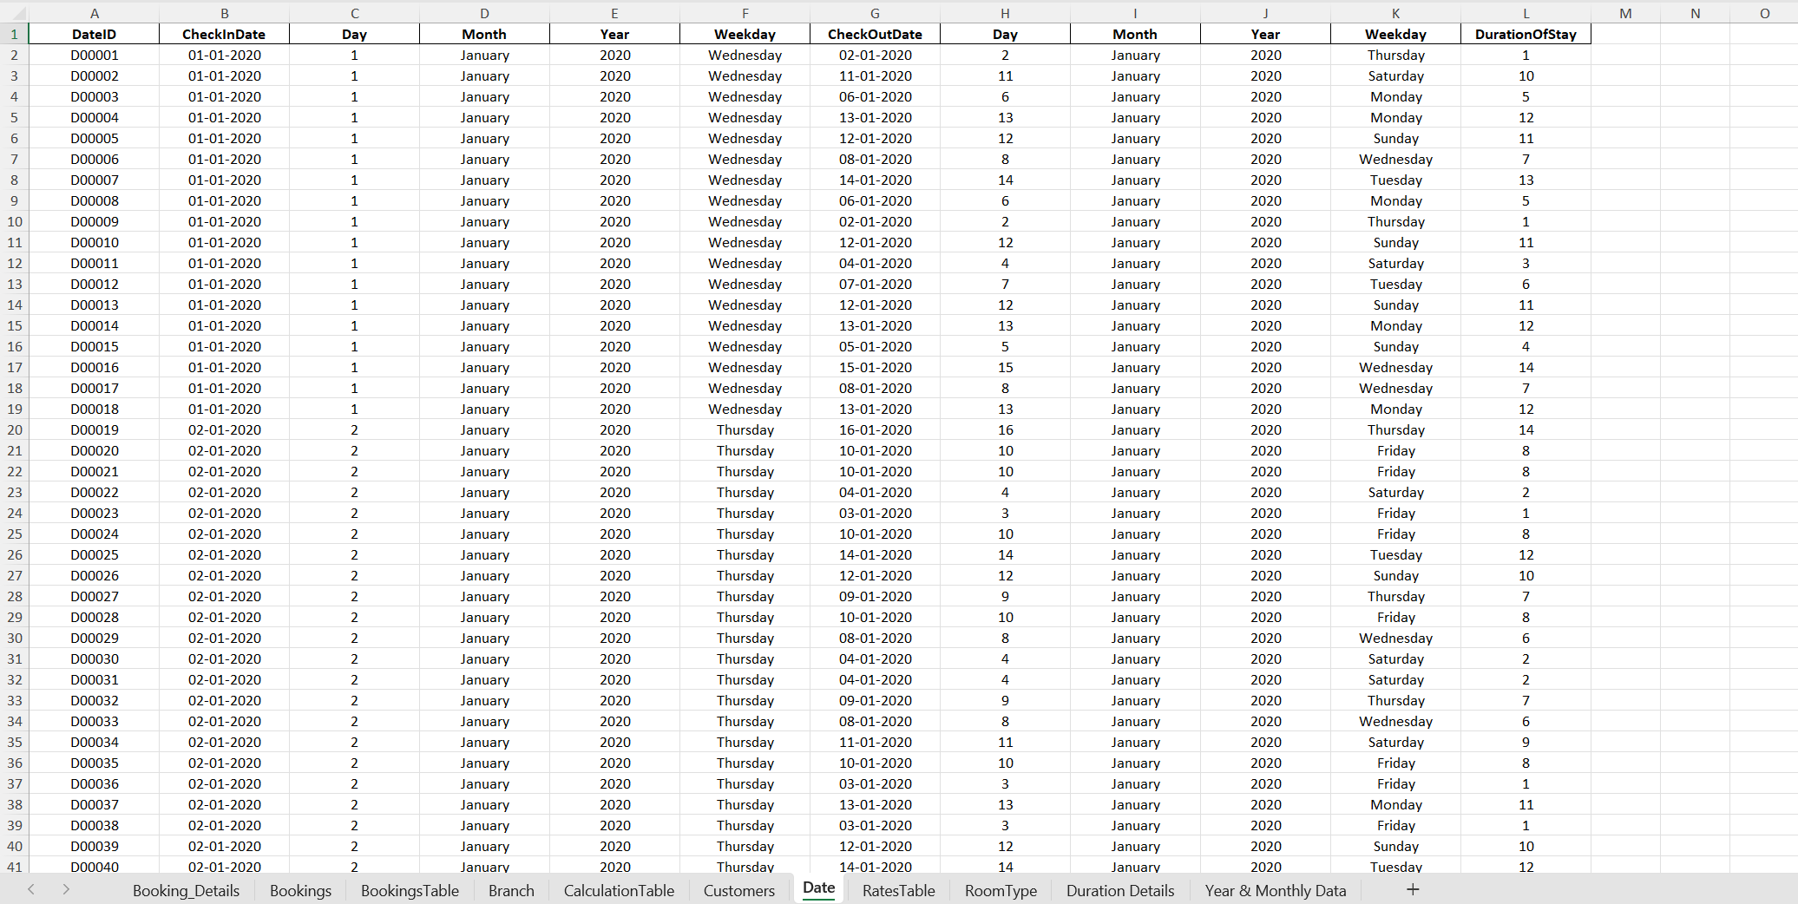

RatesTable:
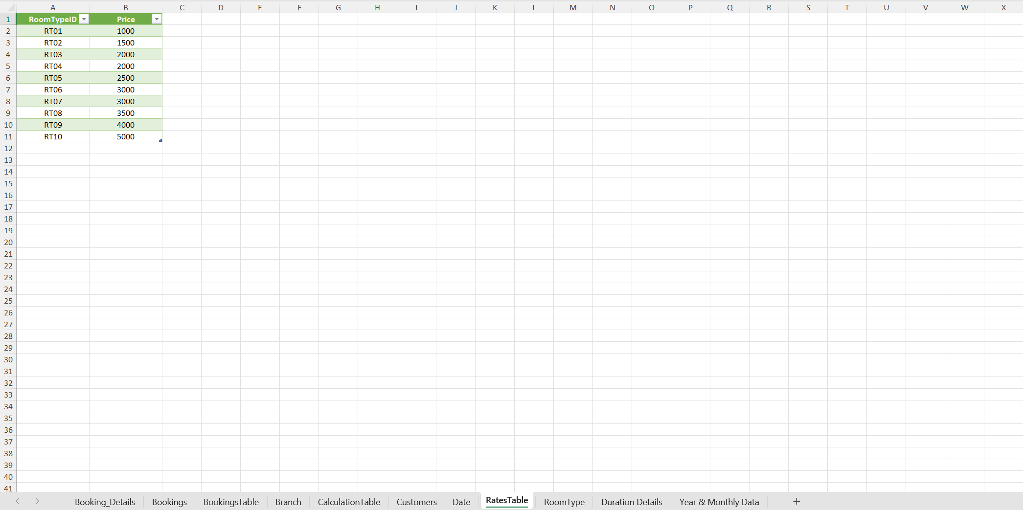

RoomType:
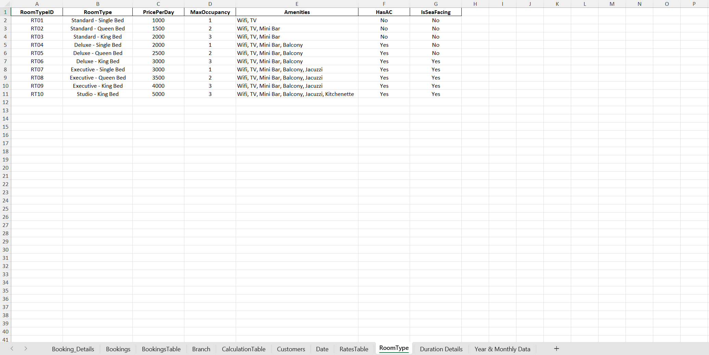

Duration Details:
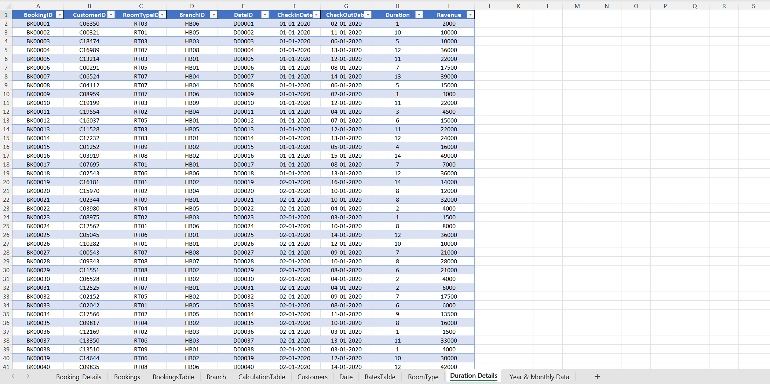

Monthly & Year Data:
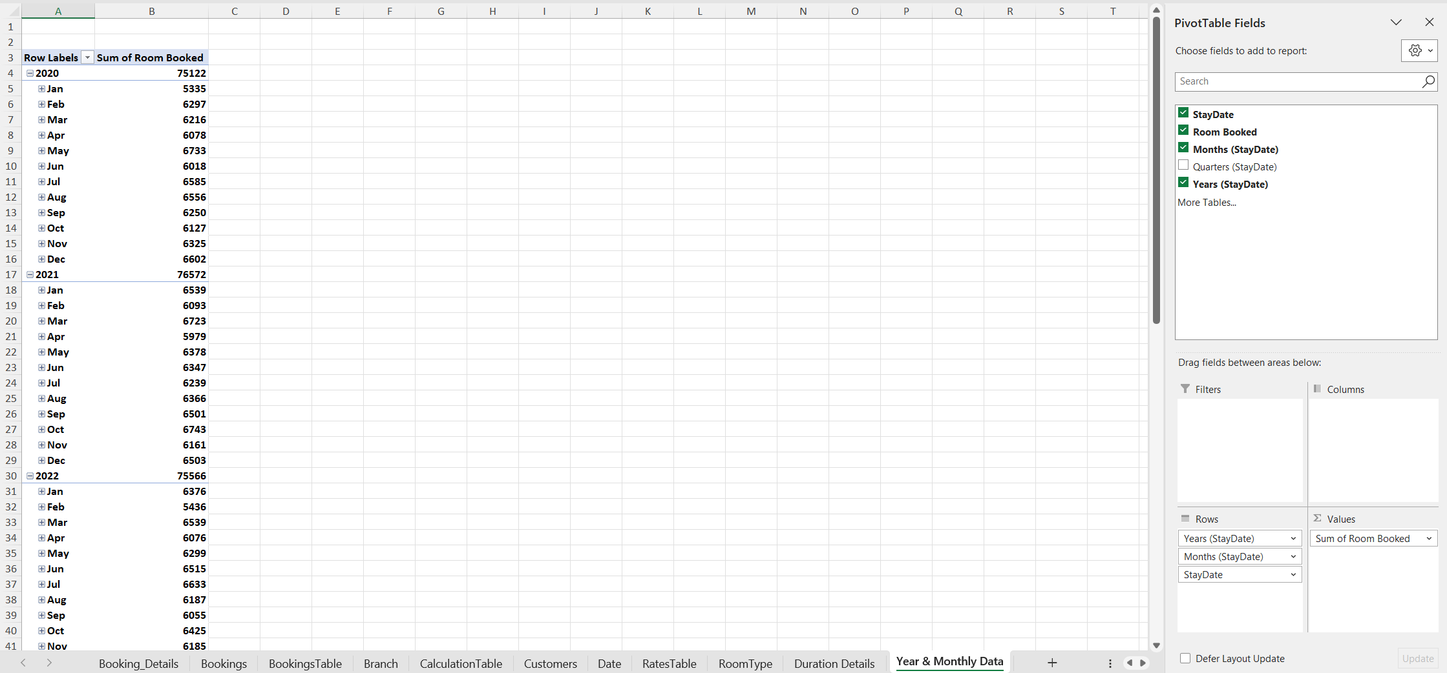

Step-3: Power-Bi
[Importing the Excel File into PowerBi would look like this:]
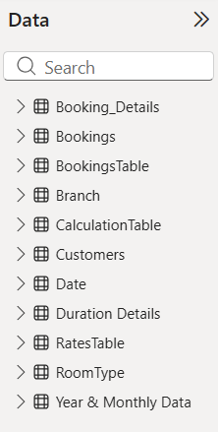

[Expanding them]
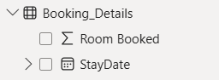
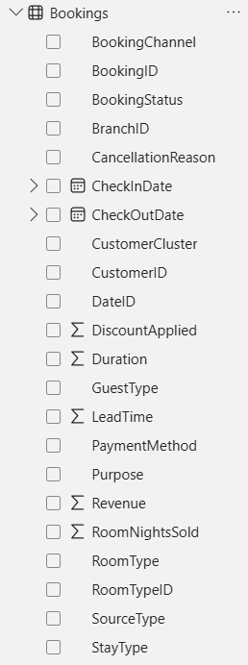
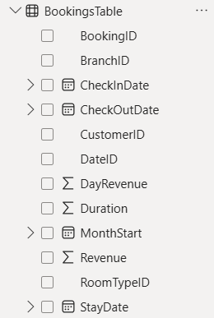
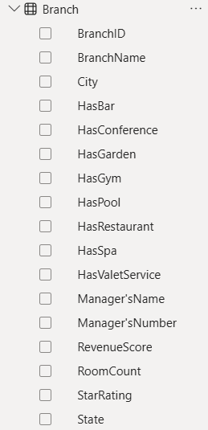
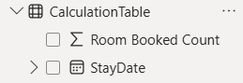
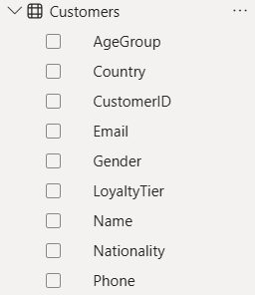
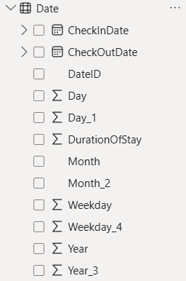
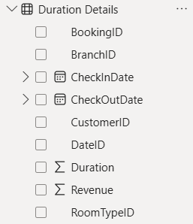
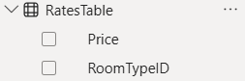
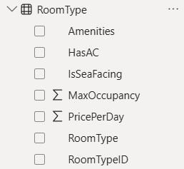
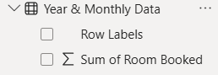

Step-4: Adding New Measures/Columns in Power-Bi

For Bookings_Details
(Original)
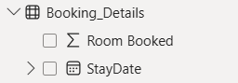
(Final)
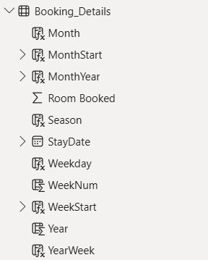

(New Column)
Name | Formula
MonthYear | MonthYear = Booking_Details[StayDate]
MonthStart | MonthStart = DATE(YEAR([StayDate]), MONTH([StayDate]), 1)
Year | Year = YEAR(Booking_Details[MonthYear])
Month | Month = FORMAT('Booking_Details'[MonthYear], "MMMM")
Season | Season = SWITCH(  TRUE(),  MONTH([StayDate]) IN {12, 1, 2}, "Winter",  MONTH([StayDate]) IN {3, 4, 5}, "Spring",  MONTH([StayDate]) IN {6, 7, 8}, "Summer",  MONTH([StayDate]) IN {9, 10, 11}, "Autumn"  )
Weekday | Weekday = FORMAT('Booking_Details'[MonthYear], "dddd")
WeekNum | WeekNum = WEEKNUM('Booking_Details'[StayDate], 2)
WeekStart | WeekStart = Booking_Details[MonthYear] - WEEKDAY(Booking_Details[MonthYear], 2) + 1
YearWeek | YearWeek =  VAR Yr = YEAR(Booking_Details[MonthYear])  VAR Wk = WEEKNUM(Booking_Details[MonthYear], 2)  RETURN Yr & "-W" & FORMAT(Wk, "00")

(New Measure)
Nil

For Bookings
(Original)
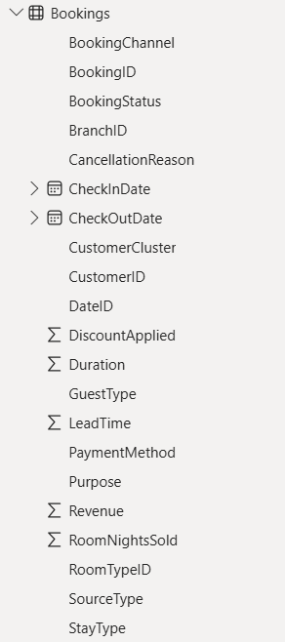

(Final)
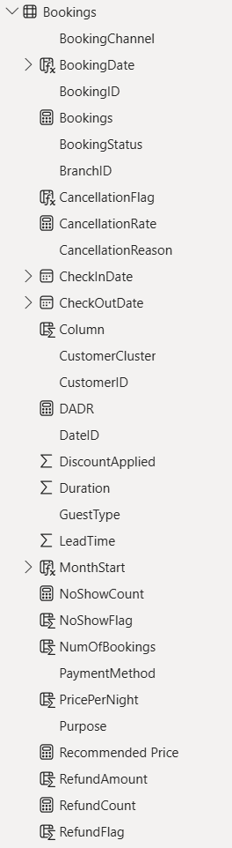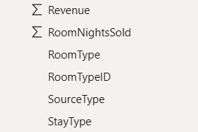

(New Column)
Name | Formula
BookingDate | BookingDate =  VAR CheckInDate = Bookings[CheckInDate]  VAR PriorMonthDate = EOMONTH(CheckInDate, -1) + 1 -- first day of prior month  VAR DaysBetween = DATEDIFF(PriorMonthDate, CheckInDate, DAY)  VAR RandomOffset = RANDBETWEEN(0, DaysBetween)  RETURN PriorMonthDate + RandomOffset
PricePerNight | PricePerNight = Bookings[Revenue]/Bookings[RoomNightsSold]
NumOfBookings | NumOfBookings =  CALCULATE(  COUNT('Bookings'[BookingID]),  ALLEXCEPT('Bookings', 'Bookings'[CustomerID])  )
CustomerCluster | CustomerCluster =  SWITCH(TRUE(),  [NumOfBookings] = 1 && [Revenue] <  5000, "First-Timer",  [NumOfBookings] >= 3 && [Revenue] <  15000, "Loyal Guest",  [Revenue] >= 15000, "High Spender",  "Other"  )
CancellationFlag | CancellationFlag = IF(Bookings[BookingStatus] = "Cancelled", "Yes", "No")
NoShowFlag | NoShowFlag = IF(Bookings[BookingStatus] = "No-Show", 1, 0)
RefundAmount | RefundAmount =  IF(  Bookings[BookingStatus] = "Cancelled",  Bookings[Revenue],  0  )
RefundFlag | RefundFlag = IF(NOT(ISBLANK(Bookings[RefundAmount])), 1, 0)
MonthStart | MonthStart = STARTOFMONTH ( 'Bookings'[BookingDate] )

(New Measure)
Name | Formula
Bookings | Bookings = COUNTROWS(Bookings)
CancellationRate | CancellationRate =  DIVIDE(  COUNTROWS(FILTER(Bookings, Bookings[CancellationFlag] = "Yes")),  COUNTROWS(Bookings)  )
DADR | DADR = AVERAGE(Bookings[PricePerNight])
NoShowCount | NoShowCount =  CALCULATE(  COUNTROWS(Bookings),  Bookings[BookingStatus] = "No-Show"  )
Recommended Price | Recommended Price =  VAR BaseADR = [DADR]  VAR SeasonAdj =  SWITCH(SELECTEDVALUE('Date'[Season]),  "High", 0.15,  "Shoulder", 0.05,  "Low", -0.10,  0  )  VAR Uplift = [Price Uplift % Value]  VAR Elasticity = [Occupancy Sensitivity Value]  RETURN  BaseADR * (1 + SeasonAdj + Uplift) * Elasticity
RefundCount | RefundCount =  CALCULATE (  COUNTROWS ( Bookings ),  Bookings[RefundAmount] > 0  )

For CalculationTable
(Original)
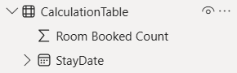
(Final)
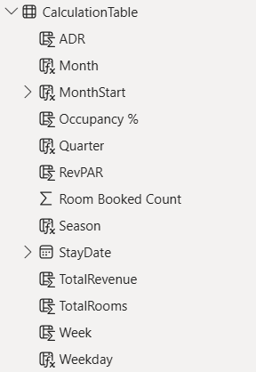

(New Measure)
Nil

(New Column)
Name | Formula
Month | Month = FORMAT('CalculationTable'[StayDate], "MMMM")
MonthStart | MonthStart = EOMONTH([StayDate], -1) + 1
Quarter | Quarter = "Q" & QUARTER('CalculationTable'[StayDate]) & " " & YEAR('CalculationTable'[StayDate])
Season | Season = SWITCH(  TRUE(),  MONTH([StayDate]) IN {12, 1, 2}, "Winter",  MONTH([StayDate]) IN {3, 4, 5}, "Spring",  MONTH([StayDate]) IN {6, 7, 8}, "Summer",  MONTH([StayDate]) IN {9, 10, 11}, "Autumn"  )
Occupancy % | Occupancy % =  DIVIDE(  'CalculationTable'[Room Booked Count],  'CalculationTable'[TotalRooms],  0  ) * 100
TotalRevenue | TotalRevenue =  CALCULATE(  SUM('BookingsTable'[DayRevenue]),  FILTER('BookingsTable', 'BookingsTable'[StayDate] = 'CalculationTable'[StayDate])  )
TotalRooms | TotalRooms = 300
ADR | ADR =  DIVIDE(  'CalculationTable'[TotalRevenue],  'CalculationTable'[Room Booked Count],  0  )
RevPAR | RevPAR =  DIVIDE(  'CalculationTable'[Occupancy %],  100,  0  ) * 'CalculationTable'[ADR]
Week | Week = WEEKNUM('CalculationTable'[StayDate], 2)
Weekday | Weekday = FORMAT('CalculationTable'[StayDate], "dddd")

For Date
(Original)
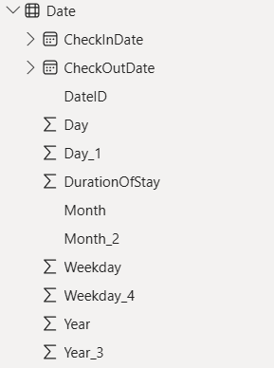
(Final)
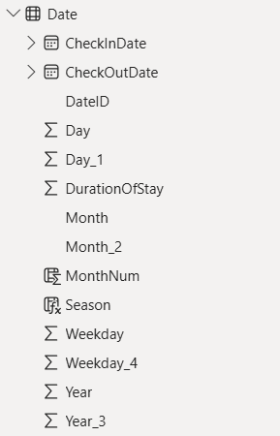

(New Column)
Name | Formula
MonthNum | MonthNum =  SWITCH(  TRUE(),  LOWER('Date'[Month]) = "january", 1,  LOWER('Date'[Month]) = "february", 2,  LOWER('Date'[Month]) = "march", 3,  LOWER('Date'[Month]) = "april", 4,  LOWER('Date'[Month]) = "may", 5,  LOWER('Date'[Month]) = "june", 6,  LOWER('Date'[Month]) = "july", 7,  LOWER('Date'[Month]) = "august", 8,  LOWER('Date'[Month]) = "september", 9,  LOWER('Date'[Month]) = "october", 10,  LOWER('Date'[Month]) = "november", 11,  LOWER('Date'[Month]) = "december", 12  )
Season | Season =  SWITCH(  TRUE(),  'Date'[MonthNum] IN {12,1,5,7}, "High",  'Date'[MonthNum] IN {2,3,8,10}, "Shoulder",  'Date'[MonthNum] IN {4,6,9,11}, "Low"  )

(New Measure)
Nil

For GuestTable
GuestTable =
SUMMARIZE(
'BookingsTable',
'BookingsTable'[CustomerID],
"FirstStay", MIN('BookingsTable'[CheckInDate]),
"LastStay", MAX('BookingsTable'[CheckOutDate])
)

(Original)
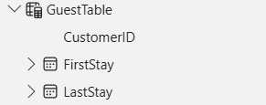
(Final)
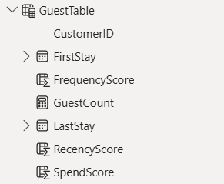

(New Column)
Name | Formula
RecencyScore | RecencyScore =  DATEDIFF(  CALCULATE(  MAX('Bookingstable'[CheckOutDate]),  FILTER('BookingsTable', 'BookingsTable'[CustomerID] = 'GuestTable'[CustomerID])  ),  TODAY(),  DAY  )
FrequencyScore | FrequencyScore =  CALCULATE(  COUNTROWS('BookingsTable'),  FILTER('BookingsTable', 'BookingsTable'[CustomerID] = 'GuestTable'[CustomerID])  )
SpendScore | SpendScore =  CALCULATE(  SUM('BookingsTable'[DayRevenue]),  FILTER('BookingsTable', 'BookingsTable'[CustomerID] = 'GuestTable'[CustomerID])  )

(New Measure)
Name | Formula
GuestCount | GuestCount = COUNTROWS('GuestTable')

For MasterData
Master Data =
VAR CalendarTable =
ADDCOLUMNS (
CALENDAR (DATE(2020,1,1), DATE(2025,11,29)),
"MonthStart", EOMONTH([Date], -1) + 1,
"Month", FORMAT(EOMONTH([Date], -1) + 1, "dd-mmm-yy"),
"DayCount", DAY(EOMONTH([Date], 0)),
"RoomAvailableCount", DAY(EOMONTH([Date], 0)) * 300
)
RETURN
ADDCOLUMNS (
SUMMARIZE (
CalendarTable,
[MonthStart], [Month], [DayCount], [RoomAvailableCount]
),
"RoomSoldCount",
CALCULATE (
SUM (Booking_Details[Room Booked]),
TREATAS ( { [MonthStart] }, Booking_Details[MonthStart] )
),
"Occupancy %",
DIVIDE (
CALCULATE (
SUM (Booking_Details[Room Booked]),
TREATAS ( { [MonthStart] }, Booking_Details[MonthStart] )
),
[RoomAvailableCount],
0
) * 100
)
(Original)
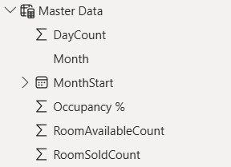
(Final)
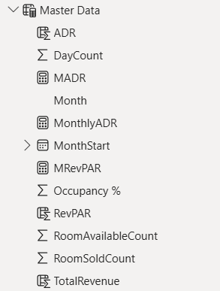

(New Column)
Name | Formula
ADR | ADR =  DIVIDE(  [TotalRevenue],  'Master Data'[RoomSoldCount]  )
RevPAR | RevPAR = [ADR] * DIVIDE('Master Data'[Occupancy %], 100)
TotalRevenue | TotalRevenue =  CALCULATE(  SUM('BookingsTable'[Revenue]),  FILTER('BookingsTable', 'BookingsTable'[MonthStart] = 'Master Data'[MonthStart])  )

(New Measure)
Name | Formula
MADR | MADR =  DIVIDE(  SUM('Bookings'[Revenue]),  SUM('Bookings'[RoomNightsSold])  )
MonthlyADR | MonthlyADR =  CALCULATE(  [MADR],  ALLEXCEPT('Master Data', 'Master Data'[MonthStart])  )
MRevPAR | MRevPAR =  DIVIDE(  SUM('Master Data'[TotalRevenue]),  SUM('Master Data'[RoomAvailableCount])  )
MonthlyRevPAR | MonthlyRevPAR =  CALCULATE(  [MRevPAR],  ALLEXCEPT('Master Data', 'Master Data'[MonthStart])  )

For MonthlyBookings
MonthlyBookings =
SUMMARIZE (
'Booking_Details',
'Booking_Details'[MonthStart],
"TotalRoomsBooked", SUM('Booking_Details'[Room Booked])
)

(Final)
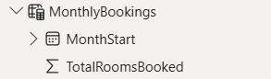

For Occupancy Sensitivity
Modeling → New Parameter → Numeric Range →What‑If Parameter
Configure:
Name: Occupancy Sensitivity
Data type: Decimal Number
Minimum: 0.8
Maximum: 1.2
Increment: 0.05
Default: 1

(Final)
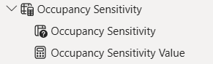

For Price Uplift %
Modeling → New Parameter → Numeric Range →What‑If Parameter
Configure:
Name: Price Uplift %
Data type: Decimal Number
Minimum: -0.10 (–10%)
Maximum: 0.20 (+20%)
Increment: 0.01
Default: 0

(Final)
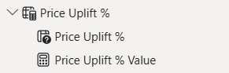
For Season
Season =
DATATABLE(
"MonthNumber", INTEGER,
"MonthName", STRING,
"Season", STRING,
{
{1, "January", "High"},
{2, "February", "Shoulder"},
{3, "March", "Shoulder"},
{4, "April", "Low"},
{5, "May", "High"},
{6, "June", "Low"},
{7, "July", "High"},
{8, "August", "Shoulder"},
{9, "September", "Low"},
{10, "October", "Shoulder"},
{11, "November", "Low"},
{12, "December", "High"}
}
)

(Final)
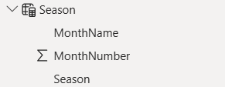

For Ancillary_Transactions
1. Open Power Query Editor
In Power BI Desktop, go to Home → Transform Data.
2. Create a Blank Query
In the left pane, click New Source → Blank Query.
Right-click the new query → Rename it to Ancillary_Transactions.
Go to Home → Advanced Editor.
Paste:
let
// Load Bookings table
Source = Bookings,

// Filter valid bookings
ValidBookings = Table.SelectRows(Source, each [CheckInDate] <> null and [CheckOutDate] <> null),

// Add ServiceType randomly
WithServiceType =
Table.AddColumn(
Table.AddIndexColumn(ValidBookings, "TempIndex", 0, 1),
"ServiceType",
each
let r = Number.Mod([TempIndex], 4)
in
if r = 0 then "Spa"
else if r = 1 then "Dining"
else if r = 2 then "Laundry"
else "Recreation"
),
// Add Item based on ServiceType
WithItem = Table.AddColumn(WithServiceType, "Item", each
if [ServiceType] = "Spa" then "Swedish Massage"
else if [ServiceType] = "Dining" then "Buffet Dinner"
else "Airport Pickup"),

// Add Quantity randomly (1 to 3)
WithQuantity = Table.AddColumn(WithItem, "Quantity", each
1 + Number.Mod(Text.Length([CustomerID]) + Number.From(Date.Day([CheckInDate])), 3)),

// Add Amount based on ServiceType and Quantity
WithAmount = Table.AddColumn(WithQuantity, "Amount", each
let base = if [ServiceType] = "Spa" then 1800
else if [ServiceType] = "Dining" then 1200
else 1000
in base * [Quantity]),

// Add Transaction Date within stay period
WithDate = Table.AddColumn(WithAmount, "Date", each
let los = Duration.Days([CheckOutDate] - [CheckInDate]),
offset = Number.Mod(Text.Length([RoomTypeID]) + Number.From(Date.Day([CheckOutDate])), los + 1)
in Date.AddDays([CheckInDate], offset)),

// Add TransID
WithIndex = Table.AddIndexColumn(WithDate, "TransID", 1, 1, Int64.Type),
Final = Table.TransformColumns(WithIndex, {
{"TransID", each "ANC" & Text.PadStart(Text.From(_), 5, "0"), type text}
}),

// Select final columns
AncillaryTable = Table.SelectColumns(Final, {"TransID", "BookingID", "CustomerID", "Date", "ServiceType", "Item", "Quantity", "Amount"})
in
AncillaryTable
(Original)
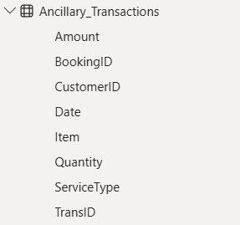

(Final)
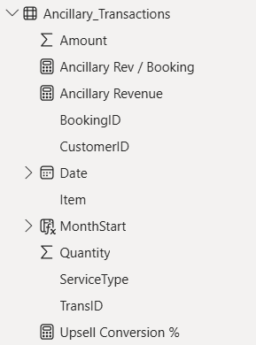

(New Column)
Name | Formula
MonthStart | MonthStart = DATE(YEAR([Date]), MONTH([Date]), 1)

(New Measure)
Name | Formula
Ancillary Rev / Booking | Ancillary Rev / Booking = DIVIDE(SUM(Ancillary_Transactions[Amount]), COUNT(Bookings[BookingID]))
Ancillary Revenue | Ancillary Revenue = SUM(Ancillary_Transactions[Amount])
Upsell Conversion % | Upsell Conversion % = DISTINCTCOUNT(Ancillary_Transactions[BookingID]) / DISTINCTCOUNT(Bookings[BookingID])

Manage Relationships Snapshot:
